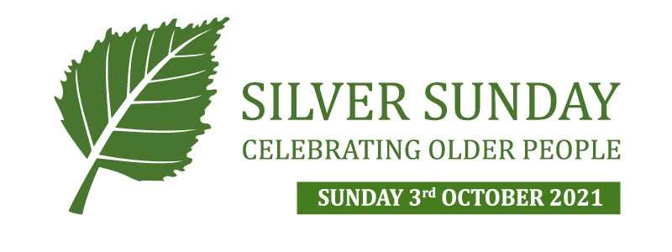

For further details please contact:
[insert name] [insert email address]
PRESS RELEASE
[YOUR ORGANISATION] to host Silver Sunday event for older people
On [date] [your organisation] will host [insert number] older residents at a [insert event name]. The event is part of a national day to overcome loneliness amongst older people that is held on the first Sunday in October.
Hundreds of organisations across the UK will come together to host free and low-cost events and activities on the same day.
With less than a month to go, older residents of [insert area] are invited to register for our event to try something new, meet new people and be part of the celebrations taking place across the country.
The day aims to combat loneliness by providing a packed schedule of free events for older people to try something new and meet new people. Whilst loneliness can strike at any age, older people are at greater risk. According to Age UK, more than a million older people say they go for over a month without speaking to a friend, neighbour or family member.
Silver Sunday is organised by the Sir Simon Milton Foundation, a charity that works to reduce loneliness and isolation amongst older people. For one day every year, Silver Sunday provides older people an opportunity to get out of the house, try new things and meet new people as well as to find out about local services that are available throughout the year.
Silver Sunday Founder, Lady Christabel Flight said: “Some people don’t like to admit they’re feeling lonely and Silver Sunday is a positive way to do something about it by meeting new people. You’re never too old to try something new and Silver Sunday is the perfect opportunity.”
Find out more about events and activities taking place across the country at silversunday.org.uk.
For more information please contact [insert your details]. Post-event photos and quotes will be available after the event.

Ends
Notes: Silver Sunday was launched in Westminster in 2012 by The Sir Simon Milton Foundation and Lady Christabel Flight, Westminster City Council’s Older People’s Champion. The project was set up to combat the loneliness experienced by older residents in the city of Westminster and to encourage community interaction through an annual day of events.
In 2013 it went national following interest from local councils, community organisations and businesses and now takes place on the first Sunday of every year. Silver Sunday 2019 is on 6th October and is set to be even bigger and better with events happening across the UK.
In 2019 Silver Sunday saw 1,200 events taking place reaching around 50,000 older people.
For more details on listings taking place across the country please visit silversunday.org.uk.

About the Sir Simon Milton Foundation
The Sir Simon Milton Foundation works to provide young people with jobs and training, and ensure that older residents are looked after and involved in a community that value their contribution.
For more information on the Sir Simon Milton Foundation visit sirsimonmiltonfoundation.com
About [your organisation]
[Insert company info]

