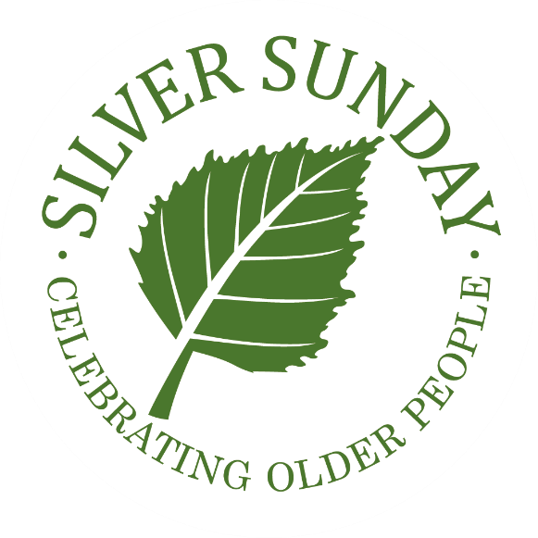

[Your Full Name]
[Address Line 1]
[Address Line 2]
[Address Line 3]
[Postcode]

[Recipient’s Full Name]
[Recipient’s Job Title]
[Address Line 1]
[Address Line 2]
[Address Line 3]
[Postcode]
[Date]

Dear [Name]

Thank you for being a part of our very special Silver Sunday celebrations this year at [venue name] in [location]. Our guests had a wonderful time with comments including [include quotes].

We are particularly grateful to [insert names and examples].

Helping to reduce loneliness amongst older people is priority for us and our [event description] is a highlight in the calendar of many local older residents. We know quite what a difference we are able to make in helping people meet new friends, connect with the community around them, learn new skills and feel a part of something uplifting and celebratory.

Thank you for all your support in making our Silver Sunday event such a success.

[Signature]

[Your name]
[Your job title]

